
Dashboard Design

Date | 27 October 2026
Team ID | Individual
Project Name | EV Market Performance & Sustainability Analytics
Maximum Marks | 5 Marks

Activity 1: Interactive and visually appealing dashboards
This Tableau dashboard presents EV market performance and sustainability indicators through KPI cards, trend charts, country and category comparisons, battery-technology analysis, range distribution, a heatmap, and a charging-efficiency scatter plot.
- Clear and Intuitive Layout
- Use Appropriate Visualizations
- Colour and Theming
- Interactive Filters and Slicers
- Drill-Down Capabilities
- Responsive Design
- Custom Visuals and Icons
- Use of Infographics

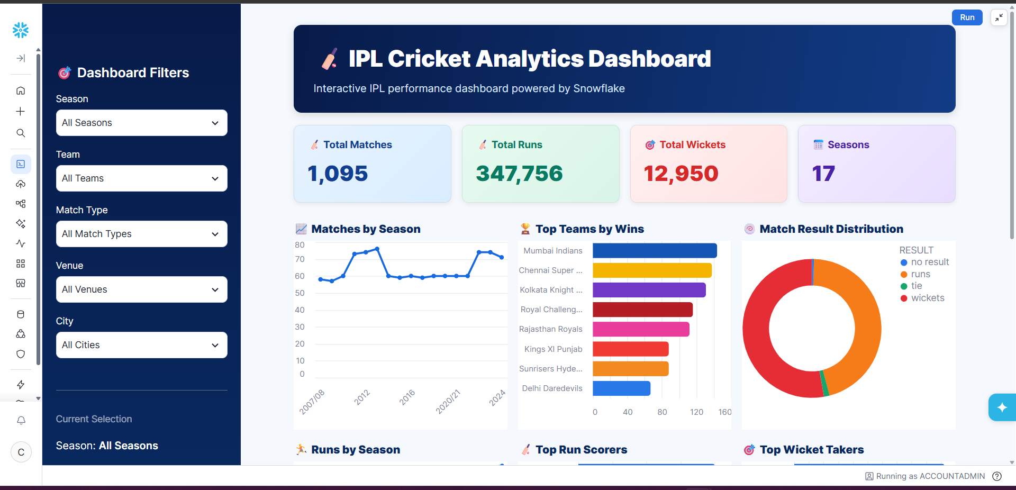
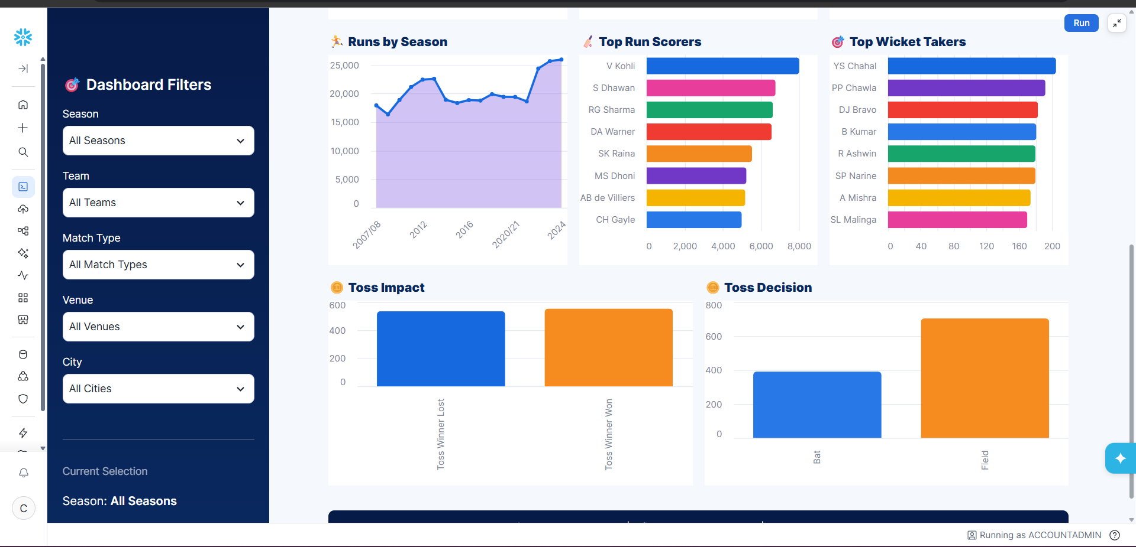
Note: Highlight the major outcomes in form of bullet points
Sample:
Major outcomes from the EV Market Performance & Sustainability Analytics dashboard:
- 1. The dashboard reports about 1.55B sales units, $64,921 average price, 324.54 km average range, and 737.93K tonnes annual CO₂ savings.
- 2. The sales-trend chart compares annual sales patterns across vehicle categories.
- 3. The country bar chart shows India and China among the leading displayed countries by recorded sales, according to this dataset.
- 4. NMC (~33.80%) and LFP (~31.99%) are the largest displayed battery sales shares.
- 5. The category donut, range distribution and heatmap compare EV segments, range variation and country/category combinations.
Overall outcome: The dashboard consolidates EV market and sustainability metrics. Validate customer-rating and charging-efficiency axes before making detailed performance claims.

Dashboard Design: EV Market Performance & Sustainability Analytics
Layout: Four KPI cards appear at the top, followed by the sales trend and manufacturing-country comparison. Vehicle-category and battery-technology donut charts appear below. A second dashboard contains manufacturer performance, range distribution, the country/category heatmap, and charging-speed versus energy-efficiency analysis.
Clear and intuitive layout: Place KPI cards first, group related charts, and use descriptive titles.
Appropriate visualisations: Line chart for trends; horizontal bars for country comparison; donut charts for category and battery shares; heatmap for country/category comparison; scatter plot for charging and efficiency; range distribution chart for category variation.
Colour and theming: Use a consistent category palette and restrained blue/neutral styling; maintain category colours across worksheets where possible.
Interactive filters and slicers: The screenshot shows Category and Model Year filters. Test each filter and confirm which worksheets it controls.
Drill-down capabilities: Use tooltips and worksheet navigation. Claim dashboard filter actions only if configured and tested.
Responsive design: Use Tableau dashboard sizing and Device Preview to check desktop and phone layouts; test rather than assume mobile responsiveness.
Custom visuals and icons: Use readable KPI labels, units, concise titles and sufficient contrast.
Infographics: The KPI row summarizes sales, price, range and CO₂ savings; donut charts summarize sales mix.

